**Lists:**

* Allow us to work with a collection of data in sequential order
* Lists are denoted by [ ] brackets and each item is separated by a comma (,)
* Lists can store *int, float, bool,* and *string* values
* Lists can also combine data types to store together in a list
* Lists can also be empty to be filled in later  
  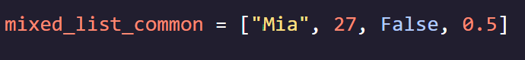  
  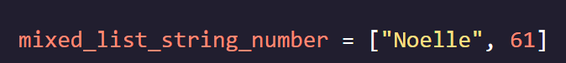  
  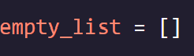

**List Methods:**

* **Method** – built in functionality that allows us to create, manipulate, and delete data
* List methods follow the format of *list_name.method()*
* ***.append()*** – allows us to add a single element to the end of a list
* **.*remove()*** – allows us to remove a sinlge specified value from a list
* ***List Concatenation (+)*** – allows us to add multiple items to a list by taking original list and appending multiple items to it using +   
  - List items HAVE to be in list form [ ] otherwise they cannot be appended

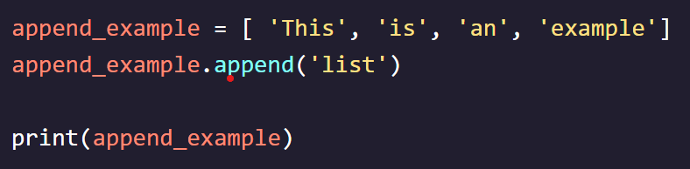

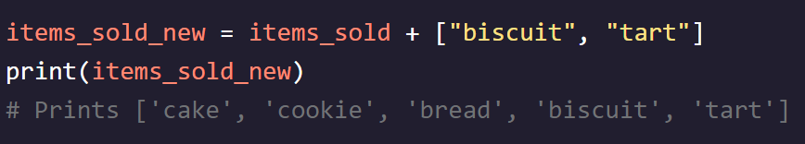

**Accessing List Elements:**

* ***Index*** – the location in the list of an element (begins at zero = ***zero indexed***)
* Can only use *int* as index value  
  - Can force results to be in *int* form by using ***int()*** around function - ***print(calls[int(4/2])***
* Can select a list element by using [ ] brackets and using number 1 less than (n-1) of desired number   
  - if we want list element 3, then we use ***print(calls[2])***